
SOUTH EAST EDUCATION DIVISION EXAMINATIONS

2026 MALAWI SCHOOL CERTIFICATE OF EDUCATION MOCK EXAMINATION

GEOGRAPHY
Subject Number: M073/I
Monday, 23 March Time Allowed: 2h 30min
8:00 - 10:30 am
PAPER I
(100 marks)
MAP READING AND PHYSICAL GEOGRAPHY
Instructions:

- This paper contains 11 printed pages. Please check.
Question Number | Tick if answered | Do not write in these columns
1
2
3
4
5
- Write your Examination number at the top of each page.
- This paper has two sections, A and B. Section A has ten questions and section B there are three questions.
- Answer all questions in the spaces provided.
- The maximum number of marks for each answer is indicated against each question.
- In the table provided on this page, tick against the number of the question you have answered.
- At the end of the examination, hand in your question paper to the invigilator.

©2026 SEED MOCK Turn over

Section A (75 marks)
Answer all the questions in this section in spaces provided
1. Study the 1:50,000 map extract of Lilongwe sheet 1433 BT and use it to answer
questions that follow.
- (i) Find the six-figure grid reference for the trigonometric station 23 NYS.
________________________________________________________
(2 marks)
(ii) Identify the human made feature located on six-figure grid reference 654335.
________________________________________________________
- mark)
- In which direction is Nalisonya river flowing?
__________________________________________________________
- mark)
- What is the altitude of the highest point on the map?
__________________________________________________________
- mark)
- If the map was reduced by half, what would be the new scale?
___________________________________________________________
- marks)
- Calculate the bearing of the trigonometric point 84 MWT from trigonometric point 126 MWT.
___________________________________________________________
- marks)
- Outline any two land uses shown on the map.
___________________________________________________________
___________________________________________________________
- marks)
continued/…
- Name any two examples of nucleated settlements shown on the map.
__________________________________________________________
__________________________________________________________
- marks)
- Calculate the actual area of land covered by Dzalanyama forest reserve, giving your answer to the nearest kilometre.

- marks)
- Measure the length of D197 road. Write your answer to the nearest kilometre.
__________________________________________________________
- marks)
- With the evidence from the map, explain any two human activities that are threatening the sustainability of Kamuzu Dam.
__________________________________________________________ ___________________________________________________________
___________________________________________________________
___________________________________________________________
- marks)

- a. (i) Mention any two geologic regions of the world where earthquakes
commonly occur
______________________________________________________
______________________________________________________ (2 marks)
(ii)Explain any two natural causes of earthquakes
______________________________________________________
______________________________________________________
______________________________________________________
______________________________________________________
(2 marks)
b. (i) With aid of well labelled diagrams, explain how block mountains are
formed by tension.

_____________________________________________________
_____________________________________________________
_____________________________________________________
_____________________________________________________
_____________________________________________________
(7 marks)
(ii). Give two examples of block mountains in Africa
_____________________________________________________
_____________________________________________________
(2 marks)
c. (i) Describe a ‘dormant volcano’
______________________________________________________
______________________________________________________
(2 marks)

(ii) Explain any two economic importance of hot springs
______________________________________________________
______________________________________________________
______________________________________________________
______________________________________________________
(4 marks)
d. (i) Explain how granite rock is formed
_______________________________________________________
_______________________________________________________
_______________________________________________________
_______________________________________________________
(3 marks)
(ii) State any three processes involved when rocks are changing to
igneous rocks
______________________________________________________
______________________________________________________
______________________________________________________
(3 marks)
3. a. Briefly explain how convectional rainfall is formed
____________________________________________________________
____________________________________________________________
____________________________________________________________
____________________________________________________________
(4 marks)
b. State any two characteristics of high clouds
_____________________________________________________________
_____________________________________________________________
(2 marks)
c (i) Define the term ‘desertification’
___________________________________________________________
___________________________________________________________
(1 mark)
(ii) Explain any two measures for controlling desertification
___________________________________________________________
___________________________________________________________
___________________________________________________________
___________________________________________________________
(4 marks)
d (i) Explain any two natural causes of climate change
___________________________________________________________
___________________________________________________________
___________________________________________________________
___________________________________________________________
(4 marks)
(ii) State any two climate change mitigation activities taking place in Malawi.
__________________________________________________________
__________________________________________________________
(2 marks)
e. Explain any two human activities that affect wild life conservation
___________________________________________________________
___________________________________________________________
___________________________________________________________
___________________________________________________________
(4 marks)

f. Figure 1 is a diagram showing a front. Use it to answer questions that follow.

Figure 1
- Identify the type of front
____________________________________________________________
(1 mark)
- When does the front in the figure develop
____________________________________________________________
____________________________________________________________
(2 marks)
- State any one weather condition associated with development of the front in the figure
____________________________________________________________
(1 mark)
Section B (25 marks)
Answer one question only from this section
4. a. Figure 2 is a map of the world showing local winds. Use it to answer questions that
follow.
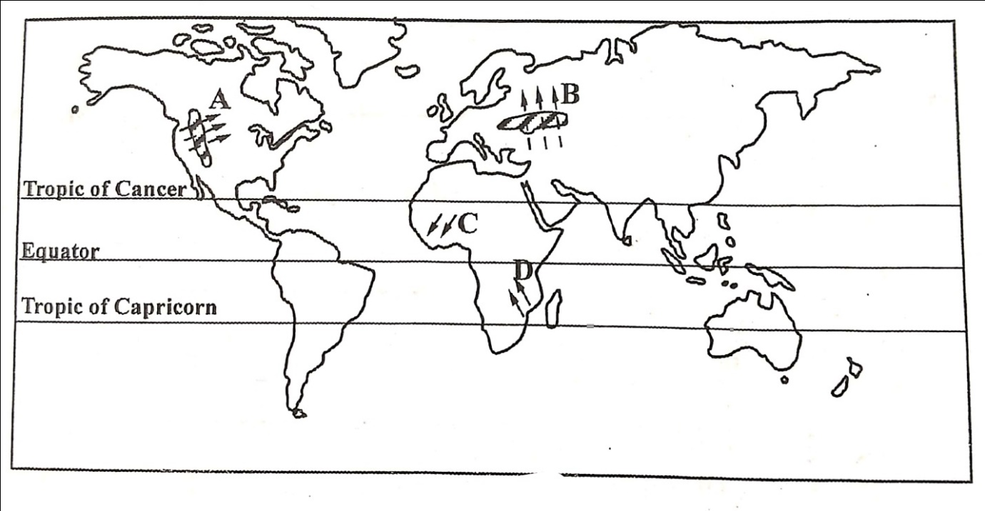
Figure 2
- Identify the local winds labelled A and C.
A: ________________________________________________________
C: ________________________________________________________
(2 marks)
- State any two characteristics of wind labelled B
______________________________________________________________________________________________________________________________ (2 marks)
- Explain any one way how wind labelled B negatively affect its region
_______________________________________________________________________________________________________________________________________
(2 marks)
- Name any one country that is affected by wind marked D ________________________________________________________________ (1 mark)
b. Table 1 shows climate data for a station in the world. Use it to answer
questions that follow.
Table 1
Month | J | F | M | A | M | J | J | A | S | O | N | D
Temp ºC | 7 | 8 | 11 | 18 | 22 | 22 | 24 | 24 | 21 | 17 | 12 | 8
Rain (mm) | 81 | 69 | 74 | 66 | 56 | 41 | 18 | 25 | 64 | 127 | 112 | 99

- Identify the type of climate represented by the climatic table.
________________________________________________________________ (1 mark)
- Briefly explain why the climatic region receives heavy rain in winter
_______________________________________________________________________________________________________________________________________________________________________________________________________________ (2 marks)
- Calculate the annual temperature range for the station.
_______________________________________________________________________________________________________________________________________ (2 marks)
- Name one country in northern hemisphere which experiences the climate
represented in the table.
_______________________________________________________________ (1 mark)
- Describe any two economic activities practised in areas experiencing the climate
represented in the table
_______________________________________________________________________________________________________________________________________________________________________________________________________________________________________________________________________________________ (4 marks)
c. (i) With an example, explain how the Coriolis force affects trade winds in the
southern hemisphere.
_______________________________________________________________________________________________________________________________________________________________________________________________________________________________________________________________________________________ (4 marks)
(ii). Explain any one economic influence of land breezes in regions they blow
________________________________________________________________________________________________________________________________________ (2 marks)
(iii). Describe the weather associated with maritime tropical air mass
_______________________________________________________________ (2 marks)

5. a. Figure 3 is a diagram showing vegetation of a certain climate in the world.
Use it to answer questions that follow.
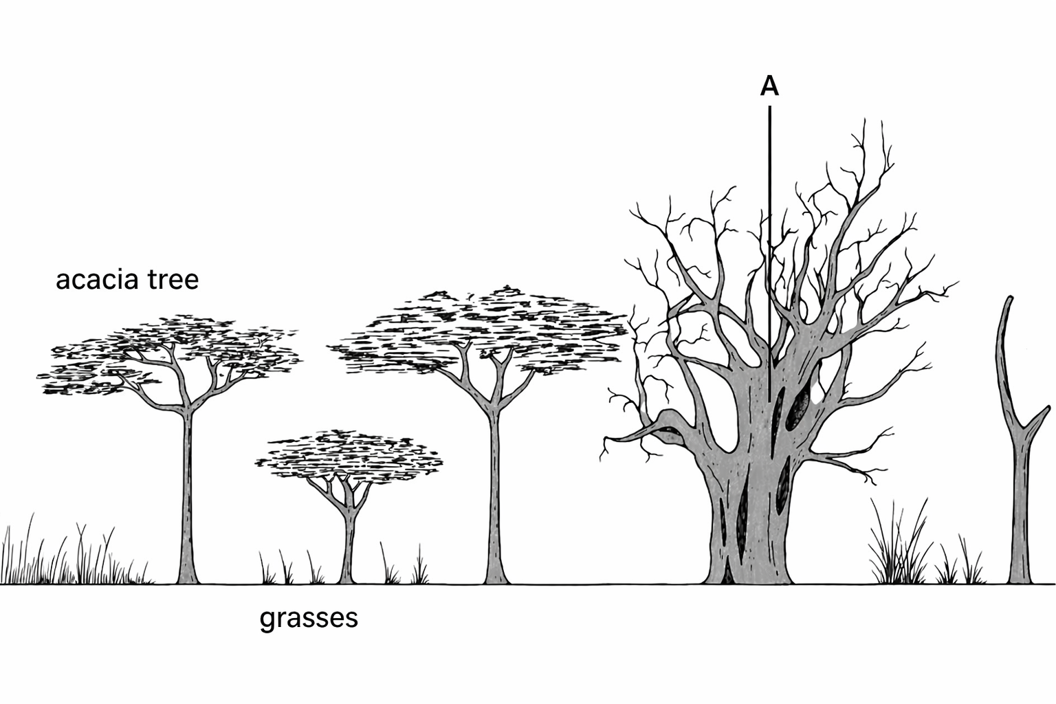
Figure 3
- Identify the type of vegetation shown in the figure
________________________________________________________________ (1 mark)
- In what type of climate is the vegetation found.
________________________________________________________________ (1 mark)
- Describe any two ways in which the tree labelled A adapts to the climatic conditions
in which it is growing
________________________________________________________________________________________________________________________________________________________________________________________________________________________________________________________________________________________________
(4 marks)
- Explain one condition that is promoting growth of grass in the type of vegetation
shown in the figure.
________________________________________________________________________________________________________________________________________ (2 marks)
- Mention one country in Southern Hemisphere where this vegetation is found
________________________________________________________________ (1 mark)
b. (i) Name any two examples of air masses based on latitude.
________________________________________________________________________________________________________________________________________ (2 marks)
(ii). Give any two characteristics of Antarctic air mass
________________________________________________________________________________________________________________________________________ (2 marks)
c. (i) Briefly explain how sea breezes develop.
________________________________________________________________________________________________________________________________________________________________________________________________________________________________________________________________________________________________
(4 marks)
(ii) Explain any one way how sea breezes affect areas they blow in
________________________________________________________________________________________________________________________________________ (2 marks)
d. Table 2 shows climate data for one of the climates in the world. Use it to answer
questions that follow.
Table 2
Month | J | F | M | A | M | J | J | A | S | O | N | D
Temp | 26 | 26 | 27 | 29 | 31 | 33 | 35 | 34 | 33 | 32 | 30 | 27
Rain(mm) | 38 | 15 | 15 | 20 | 0 | 0 | 0 | 0 | 0 | 8 | 18 | 36

- Identify the type of climate represented in the table in station
________________________________________________________________ (1 mark)
- In which hemisphere has the climate data been taken
________________________________________________________________ (1 mark)
- State any two characteristics of vegetation found in the climate in the table.
________________________________________________________________________________________________________________________________________ (2 marks)
- Name any two places in Africa which have the type of climate in the table
________________________________________________________________________________________________________________________________________ (2 marks)

END OF QUESTION PAPER
NB: This paper contains 10 printed pages.

